DIS-MEX-Chinesco-conjoined twins

Height 6.5 in. Extremely rare.

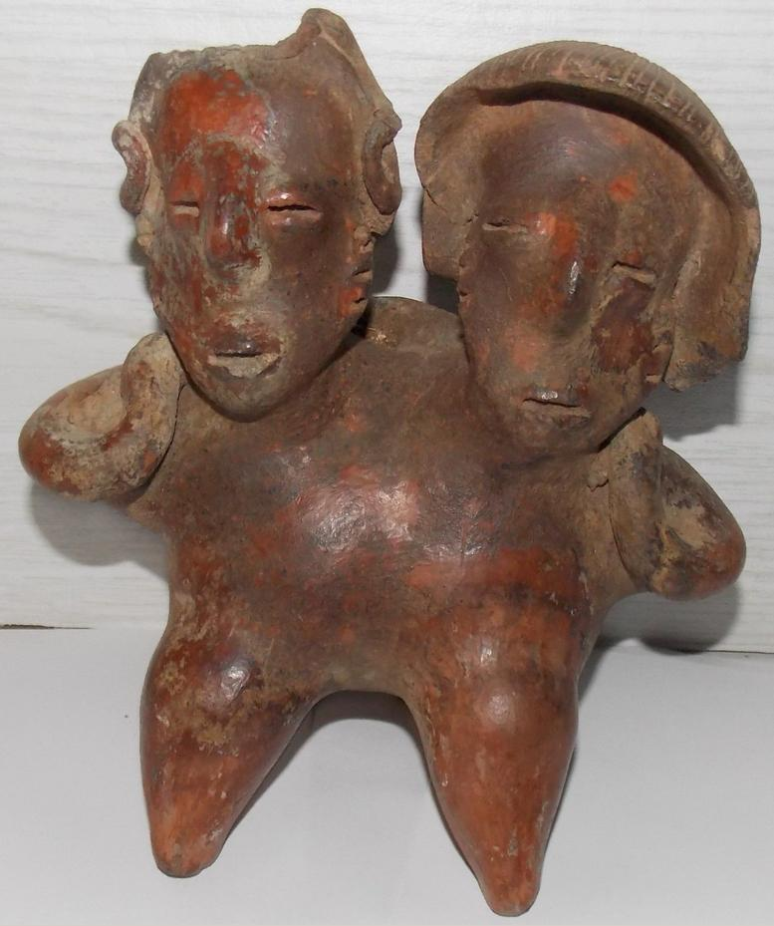 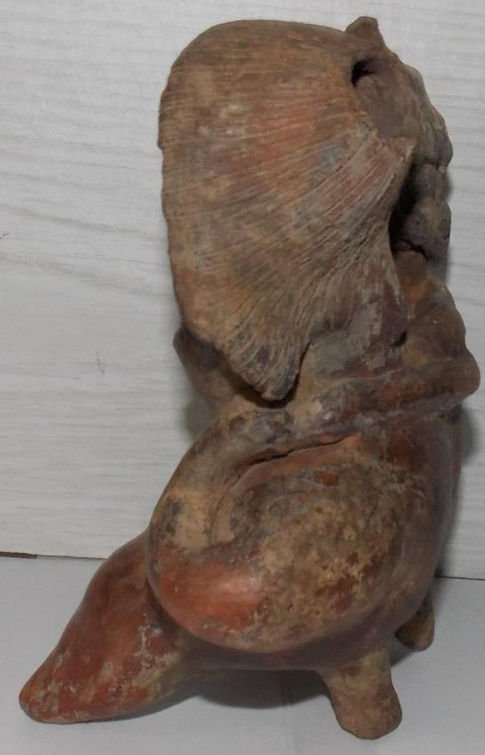 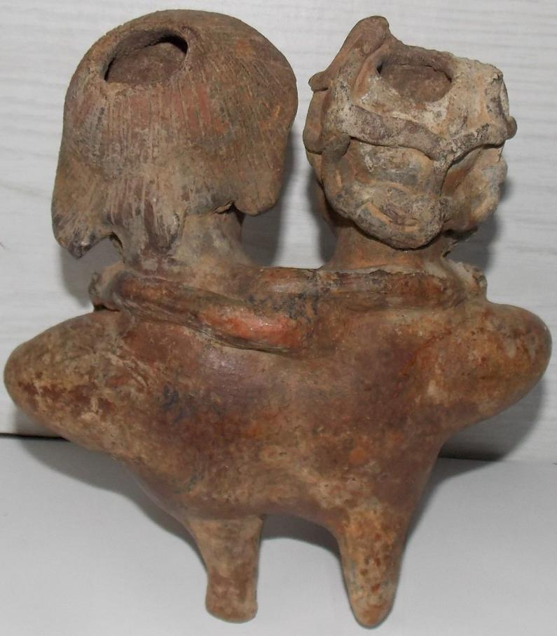 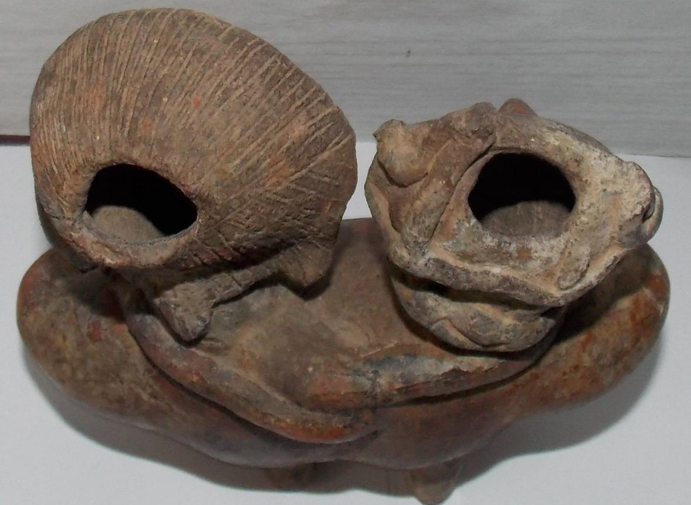 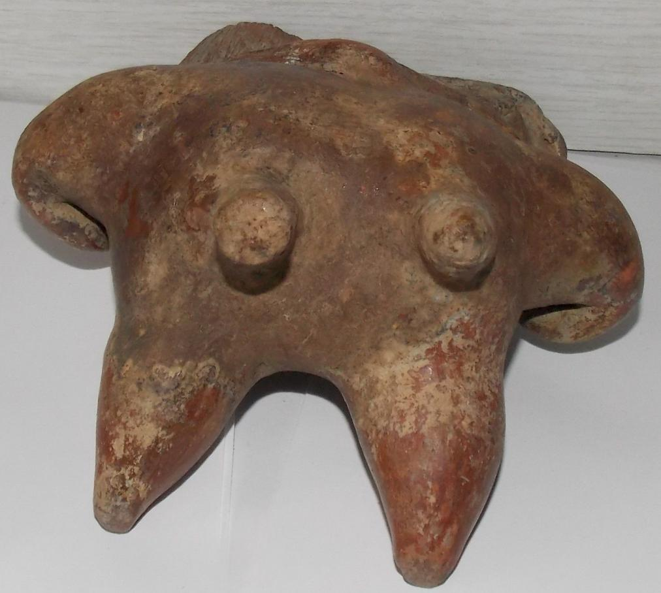

Sold by [alifeinthepastla...](http://myworld.ebay.com/alifeinthepastlane) ( [26214](http://feedback.ebay.com/ws/eBayISAPI.dll?ViewFeedback&userid=alifeinthepastlane) )

### Delivery package 1 of 1

Estimated delivery Friday, Jan 29, 2016

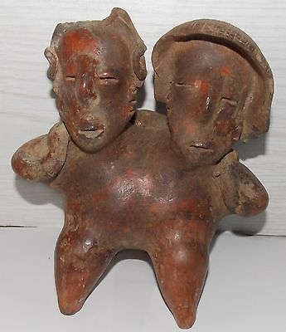

#### [ESTATE PRE-COLUMBIAN POLYCHROME HUGGING COUPLE FIGURES STATUE](http://www.ebay.com/itm/201504222075)

|  |  |
| --- | --- |
| Item price | $659.99 |
| Quantity | 1 |
| Item number | 201504222075 |
| Shipping service | Standard Shipping |

## Sales order

Sold by [tainorocksplus](http://myworld.ebay.com/tainorocksplus) ( [82](http://feedback.ebay.com/ws/eBayISAPI.dll?ViewFeedback&userid=tainorocksplus) )

### Delivery package 1 of 1

Estimated delivery Friday, Jan 29, 2016

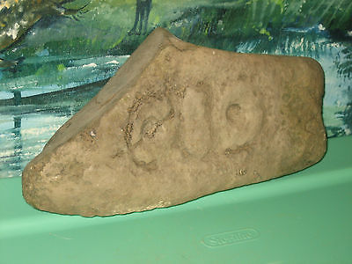

#### [TAINO - DOMINICAN REPUBLIC STONE CARVING ROCK SCULPTURE ARTIFACT FOSSIL # 19](http://www.ebay.com/itm/201491787395)

|  |  |
| --- | --- |
| Item price | $76.00 |
| Quantity | 1 |
| Item number | 201491787395 |
| Shipping service | Standard Shipping |

## Sales order

Sold by [l.orcino](http://myworld.ebay.com/l.orcino) ( [843](http://feedback.ebay.com/ws/eBayISAPI.dll?ViewFeedback&userid=l.orcino) )

### Delivery package 1 of 1

No estimate available

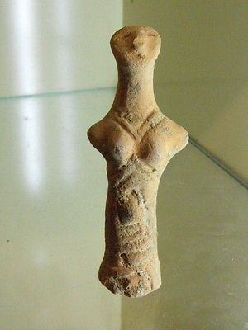

#### [RARE NEOLITHIC CLAY IDOL](http://www.ebay.com/itm/231815194921)

|  |  |
| --- | --- |
| Item price | $177.50 |
| Quantity | 1 |
| Item number | 231815194921 |
| Shipping service | Standard Shipping from outside US |

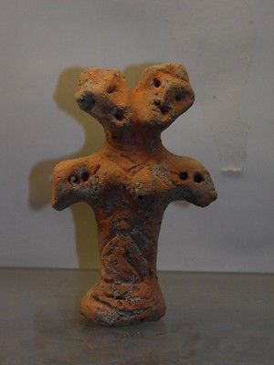

#### [ANCIENT NEOLITHIC CLAY IDOL](http://www.ebay.com/itm/231815202200)

|  |  |
| --- | --- |
| Item price | $222.50 |
| Quantity | 1 |
| Item number | 231815202200 |
| Shipping service | Standard Shipping from outside US |